**7D FROM HEXADECIMAL TO DECIMAL**

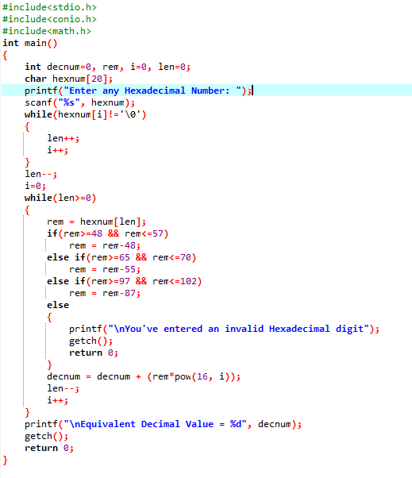

**OUTPUT**

